**RewriteETH_DST**

1. 測試內容：

測試L2 Rewrite “ETH_DST”是否正確運行

1. 測試環境組態：

* Switch: DGS-3630
* Hosts:
  + ubuntu 16.04.5 LTS
  + dlinktest1(實體機)
    - IP: 192.168.205.1
    - MAC: 00:ad:24:b1:d5:2c
    - Port: 1
  + dlinktest2(實體機)
    - IP: 192.168.205.1
    - MAC: b0:c5:54:ff:f4:59
    - Port: 2
* Apps:

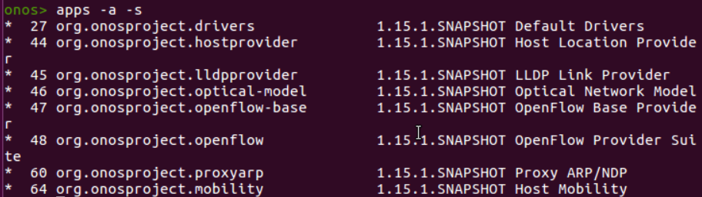

1. 使用之JSON文件：
   1. Flow Rule: (附檔：flowethdst.json)

|  |
| --- |
| {  "flows": [  {  "priority": 100,  "timeout": 0,  "isPermanent": true,  "deviceId": "of:000078321bdf4000",  "treatment": {  "instructions": [],  "deferred":[  {  "type": "GROUP",  "groupId": 268500994  }  ]  },  "selector": {  "criteria": [  {  "type": "IN_PORT",  "port": "1"  }  ]  }  }  ]  } |

* 1. Group Rule:

附檔：group1-1.json

|  |
| --- |
| {  "type": "INDIRECT",  "appCookie": "0x2234abc3",  "groupId": 268500994,  "buckets": [{  "treatment": {  "instructions": [  {  "type": "L2MODIFICATION",  "subtype": "ETH_DST",  "mac": "d0:94:66:5c:45:1f"  },  {  "type": "GROUP",  "groupId": 65538  }  ]  }  }]  } |

附檔：group2-2.json

|  |
| --- |
| {  "type": "INDIRECT",  "appCookie": "0x1234abc3",  "groupId": 65538,  "buckets": [{  "treatment": {  "instructions": [{  "type": "OUTPUT",  "port": 2  }]  }  }]  } |

1. 測試步驟：

1. 鏈接test1&test2

* ssh dlinktest1@140.113.131.146
* ssh dlinktest1@140.113.131.147

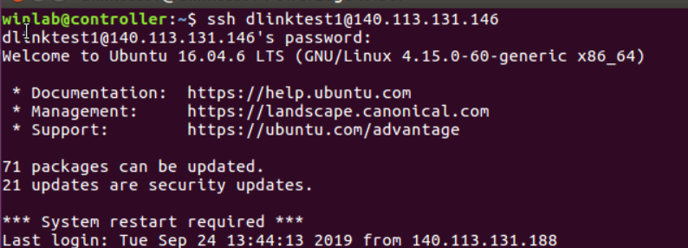

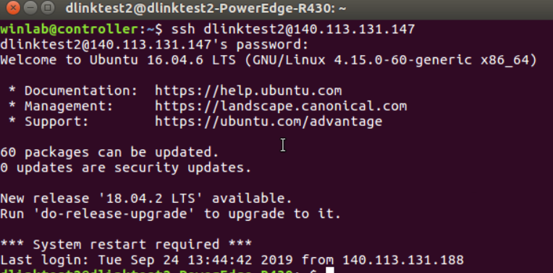

2. 鏈接DGS 3630，並查看group

* ssh admin@192.168.20.201
* show openflow group

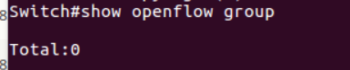

3. 寫入group rule

* curl –u onos:rocks –X POST –H “Content-type: application/json” -d @group2-2.json http://localhost:8181/onos/v1/groups/of:000078321bdf7600
* curl –u onos:rocks –X POST –H “Content-type: application/json” -d @group1-1.json http://localhost:8181/onos/v1/groups/of:000078321bdf7600

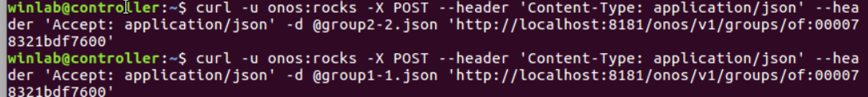

4.在Gui查看是否group安裝成功



1. 透過switch cli 查看group

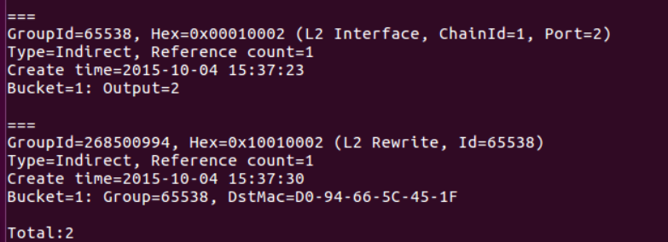

1. 安裝flow rule

* curl -u onos:rocks -X POST -H "Content-type: application/json" -d @flowethsrc.json http://localhost:8181/onos/v1/flows



1. 在GUI中查看flow是否安裝成功

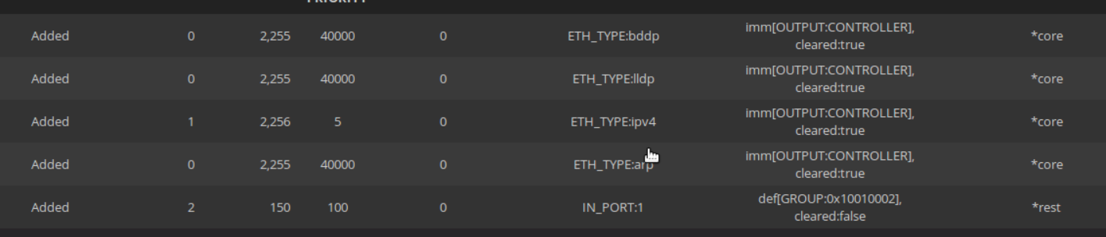

1. test1 ping test2

* ping -c 5 -I enp4s0 192.168.205.2

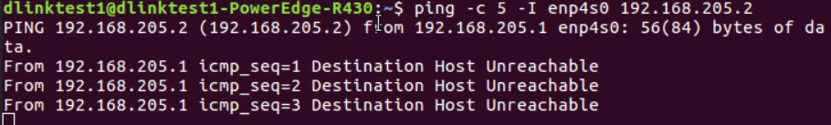

1. test2用tcpdump監控

* ping -c 5 -I enp4s0 192.168.205.1

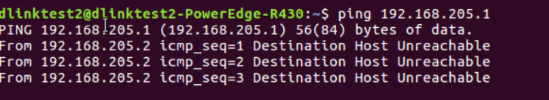

5.測試結果：

L2 Rewrite “ETH_DST”正確安裝，但没ping通